NYSSLS Daily Lesson Plan
Instructional Unit:  Weather and Climate –  Air masses, Fronts and Weather  LESSON: Weather Instruments |  |  |  |  |  | Period(s) of Unit:  2 periods |  | Date:
Materials/Resources/Links:  NONE |  |  |  |  |  |  |  | Course:  Earth and Space Science
Special Notes for Lesson:

Anchoring Phenomenon – How are weather variables measured/how is weather data collected?

Standards:
Science and Engineering Practices  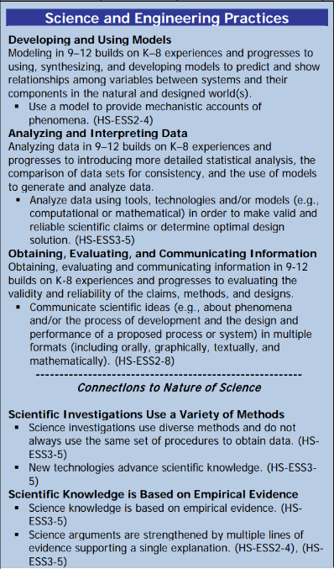 |  |  | Disciplinary Core Idea(s)  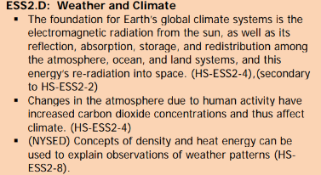 |  |  |  | Cross Cutting Concepts  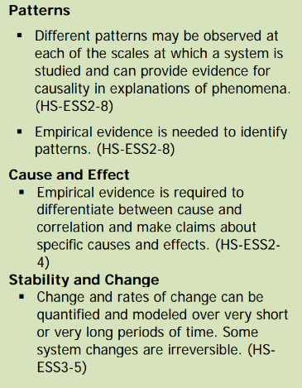
Performance Level
NYS Level 5 | NYS Level 4 |  |  | NYS Level 3 | NYS Level 2 |  |  | NYS Level 1
Collect and analyze global and regional weather data using tools, technologies, and /or models to communicate in multiple formats how the movement and interactions of airmasses result in changes in weather conditions. | Evaluate data and communicate information to explain how the movement and interactions of air masses result in changes in weather conditions |  |  | Evaluate data and communicate information to identify patterns of movement and/or the resulting changes in weather conditions. | Use data to identify the patterns of movement or the interactions of air masses and the resulting change in weather conditions  or to identify factors that drive the movement of air masses or from given weather conditions, identify evidence from maps that support these conditions. |  |  | Use data and/or patterns of movement and interactions of air masses to identify the resulting changes in weather conditions or identify one factor that drives the movement of air masses or from those provided, use evidence from maps to account for weather conditions or given weather conditions, identify evidence found on maps that account for one of these conditions.
Clarification Statement  Examples of evidence sources could include station models, surface weather maps, satellite images, radar and accepted forecast models. Emphasis should focus on communicating how the uneven heating of the Earth’s surface at frontal boundaries and resulting weather phenomena. |  |  |  |  | Assessment Boundary  Analysis is limited to surface weather maps and general weather patterns associated with High and Low pressure systems
Connection to Anchoring Phenomenon:

For discussion of Weather variables students must know how these variables are measured and quantified.

Essential Question(s):

What is the name of your instrument?

What does your instrument look like?

What weather variable does your instrument measure?

Instructional Strategies & Learning Tasks: Engage, Explore, Explain, Elaborate, Evaluate
Engage: images, video clip or data… |  | Students will randomly be assigned a weather instrument,
Explore: Students investigate, experiment, hands-on activity…. |  | Students investigate what weather variable the assigned instrument measures and find pictures of the instrument
Explain: Students share their observations and evidence to explain their understanding…possible whole group/class discussion… |  | Students will present their weather instrument to the class. They will include a picture of the instrument and a description of the weather variable (s) it measures.
Elaborate: Students apply the science concepts they’ve just learned… |  | A weather report/forecast will be shown. Students will relate the weather variables discussed in the weather report to the weather instrument used to measure it.
Evaluate (Formative Assessment): Student learning is evaluated. |  | Students will be evaluated based on their presentations. Answers to teacher questions as well a quiz and test

Copy and paste student worksheets below:

